# 

|  |
| --- |
| Difference Between NAAC & NBA Accreditation - Haq Se EngineerPREC LONIJai Shriram Engineering College (@JSREC09) / Twitter**JAI SHRIRAM ENGINEERING COLLEGE**  **TIRUPPUR – 638 660**  Approved by AICTE, New Delhi & Affiliated to Anna University, Chennai  Recognized by UGC & Accredited by NAACandNBA (CSE and ECE) |

**DEPARTMENT OF**

**ELECTRONICS AND COMMUNICATION ENGINEERING**

**IBM - Naan Mudhalvan**

**Internet of Things**

**Group 3**

**Phase 2 - Innovation**

**Title: Traffic Management**

**NAME : Monisha E**

**NM ID :AU711221106017**

**YEAR : III**

# TRAFFIC MANAGEMENT SYSTEM

Phase 2: INNOVATION

**INTRODUCTION:**

Traffic management system is one of the major proportions of a smart city. With the rapid growth of population and rapid increase of vehicles across the whole country which further leads to the traffic Congestion which is usually seen on roads. Nowadays traffic congestion is a difficult issue to deal with the number of vehicles is increasing day by day. To tackle various issues of traffic on roads and to help authorities in proper planning, a smart traffic management system using the Internet of Things (IOT) is proposed in this paper. A simple, effective and less costly method is used to optimize traffic flow on roads and an algorithm is devised to manage various traffic situations efficiently and automatically. For this purpose, the system takes traffic density as input from 8 different sensors which are there in 4 lanes which manage traffic signals. Besides this manual control of this system using Wi-Fi is also used to prioritize the emergency vehicles such as ambulances and fire brigade vehicles during a traffic jam, so that we can open the specific lane with the remote using Wi-Fi. To show the effectiveness of this proposed traffic management system, a prototype is developed which optimizes the traffic having less cost and is very effective. And the real time data will also be visible in the mobile phone through application.

**EXISTING SYSTEM:**

The existing System is generally controlled by traffic police. The main drawback of our system which is controlled by traffic police is that the system is not smart enough to deal with the traffic congestion. The traffic police official can either block a road for more amount of time or let the vehicle on the other road pass by i.e. the decision making may not be smart enough and it entirely depends on the official’s decision

**DISADVANTAGES OF EXISTING SYSTEM:**

* Traffic Congestion
* No means to detect traffic congestion
* Number of accidents are more
* It cannot be remotely controlled
* It requires more manpower
* It is less economical
* It is not efficient.

**\**

**PROPOSED SYSTEM:**

* The first and primary element of this system is the wireless sensor nodes consists of sensors. The sensors interact with the physical environment means vehicles presence or absence while the local server sends the sensors data to the central micro controller.
* The micro controller receives the signal sent from the sensors and computes which road or which lane has to be chosen based on the density of traffic or no of car.

**ADVANTAGES OF PROPOSED SYSTEM:**

* Minimize number of traffic
* Reduce fuel cost and saves time and money.
* Low budget.
* Easy implementation.
* Remotely controllable.
* It is more efficient.
* Requires less man power.

**IOT (Internet of Things)**

It refers to a system consisting of inter related internet connected object that are able to collect and transfer data Over a wireless network[6]. In this proposed system, it consists of ARDUINO, IR sensor, Wi-Fi modules.

IR sensors will capture the density of each one so the traffic light time will be assigned on the basis of data Collected through it.

**SYSTEM DESIGN AND ARCHITECHTURE:**

1. ARDUINO NANO:

An 8 bit Microchip AVR which is small, complete and bread board friendly board based on the Atmega328. It is The main CPU of our Project, in which we all the program will run.

2.POWER SUPPLY MODULE:

A power supply is a hardware component that provides power to any electrical device.

3.IR SENSOR:

These sensors are used to detect the object through infrared rays. The rays which are thrown from the sensors are Reflected back by the object by which it encountered and then after captured by these infrared sensors which Further gets converted into electric signals. These sensors are put sideways for giving us the density of vehicles in The specific lane. Infrared sensors are used for signal control, detection of pedestrians in crosswalks and Transmission of traffic information [8]. The basic disadvantages of infrared sensors are that the operation of theSystem may be affected due to fog; also installation and maintenance of the system is tedious [5,9].

4.WIFI MODULE:

It is used to give microcontroller access to your wife network.

5.RFRX MODULE:

It consists of RF transmitter and RF receiver; it is used for transmitting and receiving data.

6.LED:

Light bulbs are used for output and instruction for this system.

7.BLYNK APP:

It is a mobile application for output and verification for real time data collected.

**BLOCK DIAGRAM:**

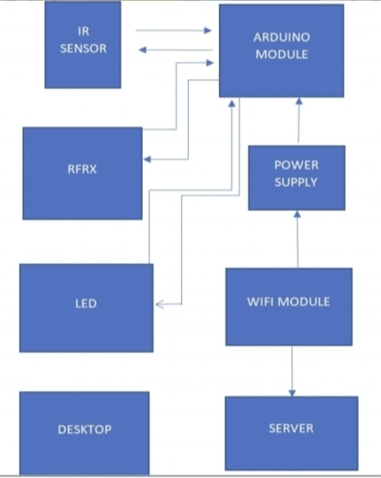

**WORKING PRINCIPLE:**

There will 8 sensors across the 4 lanes with each lane having 2 sensors each, to give the data how much dense the lane is. If in case the entire lanes have less traffic then the system will work normally means the lanes sequence will be first A lane then B lane, then C lane and at last D lane. But in case if any of the lane gets more cars or gets denser then the other 3 lanes then that specific lane will open then the other with the second highest denser, then the same order continued to the other 2 lanes. If in case all the lanes have same number of vehicles then all the lanes will open in same order i.e. A, B, C, D. If in case there is an emergency vehicle that can be ambulance, fire brigade or an emergency scout team then we have a separate Wi-Fi module through which we can open can lane in which the emergency vehicle is arrived.